**Table of content:**

**1.** **Logging to ATM’s**

**2.** **Chip and pin issues**

**Troubleshoothing**

**3.** **Printers**

**a)** **TTP2030**

**b)** **STAR**

**c)** **TUP992**

**4.** **XML configuration**

**5.** **Touchscreen**

**a) calibration**

**b) services**

**c) Kiosk.ini**

**4.** **XML configuration**

1. **Logging to ATM:**

All atm’s can be accessed from cineworld jumpbox:

-Pd001p-JumpTS01

-Pd001p-JumpTS02

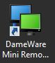You can connect to ATM’s using “dame ware”.

This software can be found on every jumpobox

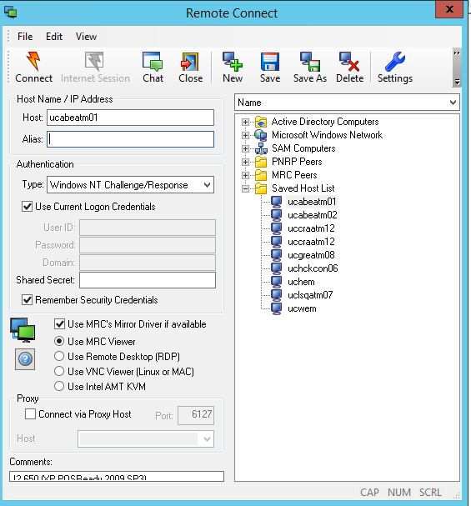The **hostname** for ATM’s is always ucXXXatmYY

Where:

-XXX is site id. For Aberdeen Queens Link this is ABE.

-YY is the number of ATM. For atm number 1 this will be 01

For Aberdeen Queens Link atm number 1 hostname will be “ucabeatm01”

As authentication use

“Windows NT Challenge/Response and tick “Use Current Logon Credentials”

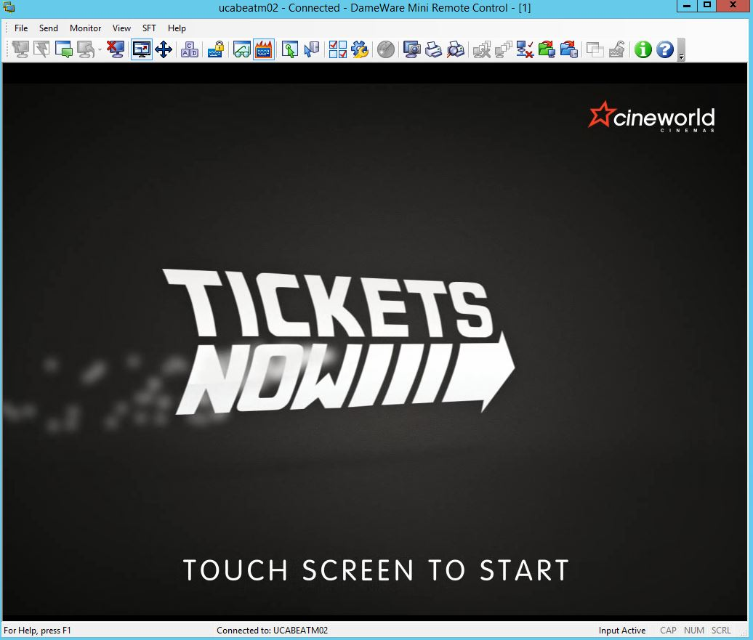After login to ATM you should either see cineworld screen saver or cineworld app running

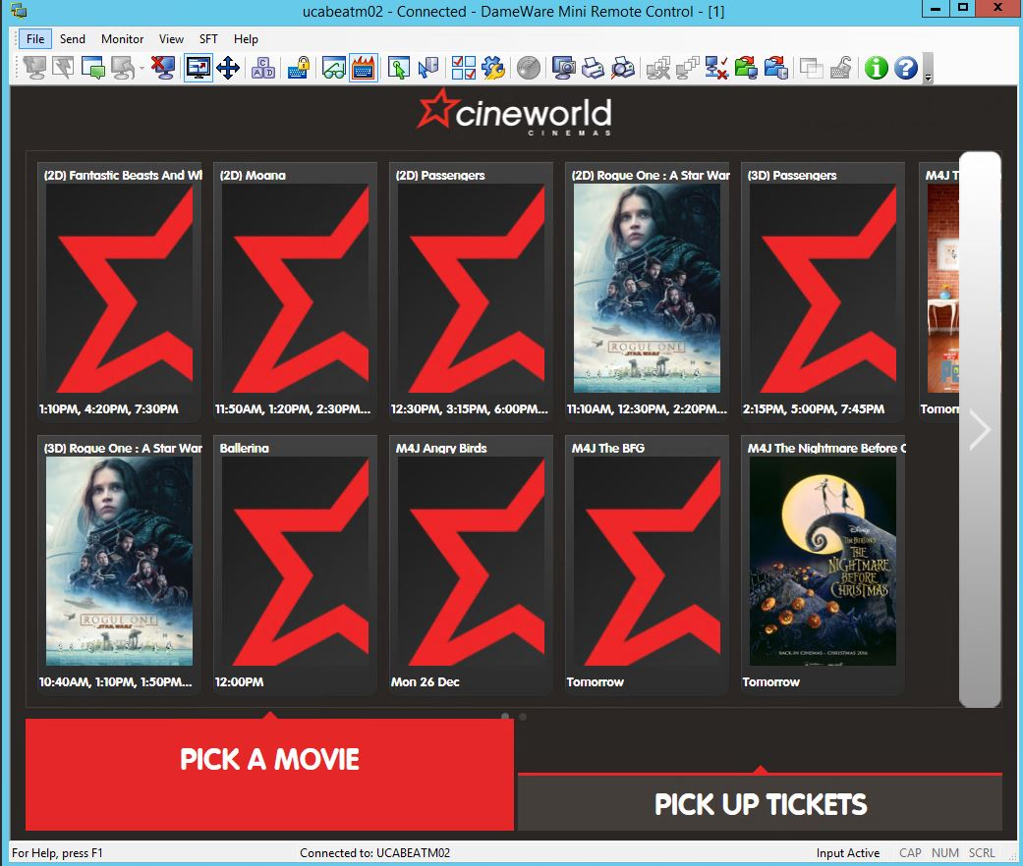

In order to fix most issues you need to re-log to admin account

Press “Control Alt Delete” icon on dameware taskbar



After that proceed with “switch user”. Press “CAD” icon once more and pick “other user”

Type in administrator credentials:

Username: administrator

Password: *search in Keepass for “POS/ATM/Manager PC Local Administrator Post Group Policy Applying”*

1. **Card reader issues:**

**Troubleshooting and hot-fixes**

**-On atm user (ucxxxp-atm), when vista is running check those points:**

1. **After rebooting ATM does ocius start only once on ATM user in background?**
2. **Ocius is starting only once after reboot-**

**Solution: Proceed with troubleshooting by attempting to pay for a movie.**

1. **Ocius is starting two times after reboot-**

**Solution: disable Ocius autostarting in “Msconfig” and “startup”**

1. **When attempting to pay for a movie, is ocius logging in background?**
2. **Ocius is logging, but it is still not accepting card payment**

**Solution: reinstall and configure ocius.**

1. **Ocius does not log in in background: Proceed to troubleshoot on administrator.**

**Troubleshooting on administrator:**

**When trying to log in manually to ocius by typing in site login and pin:**

1. **Ocius does log in, however it did not log in on atm user before.**

**Solution:**

**-make sure security settings are correct on “comidea” folder**

**-Check for temporary profile and fix it.**

1. **Ocius won’t log in on administrator account:**

**Solution: Check if PED is being detected, if not this is a hardware issue.**

**If PED is detected:**

**uninstall ocius and delete Comidea regedit entry, after that install and configure PED from scratch.**

**Detailed troubleshooting guide:**

**ON atm user when vista is running:**

There are two things to check when starting troubleshooting PED on ATMs:

1. Is ocius starting only once after reboot:

Reboot the ATM. After rebooting, when vista is running, press “alt +tab”.

This is the way it should look like:

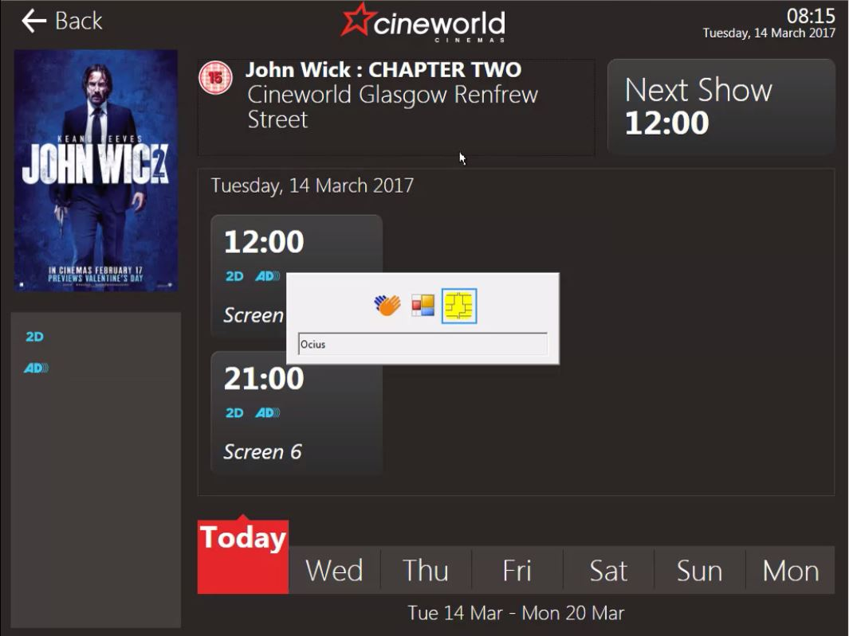

On this stage PED will show “Ocius disconnected”.

Pick any movie and proceed to payment

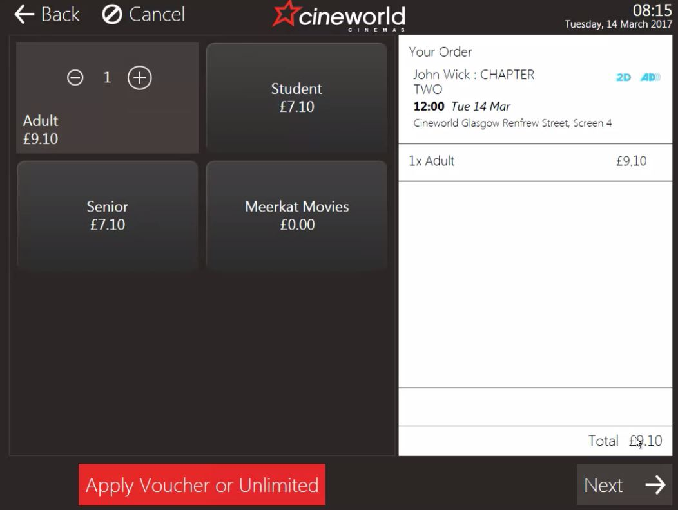

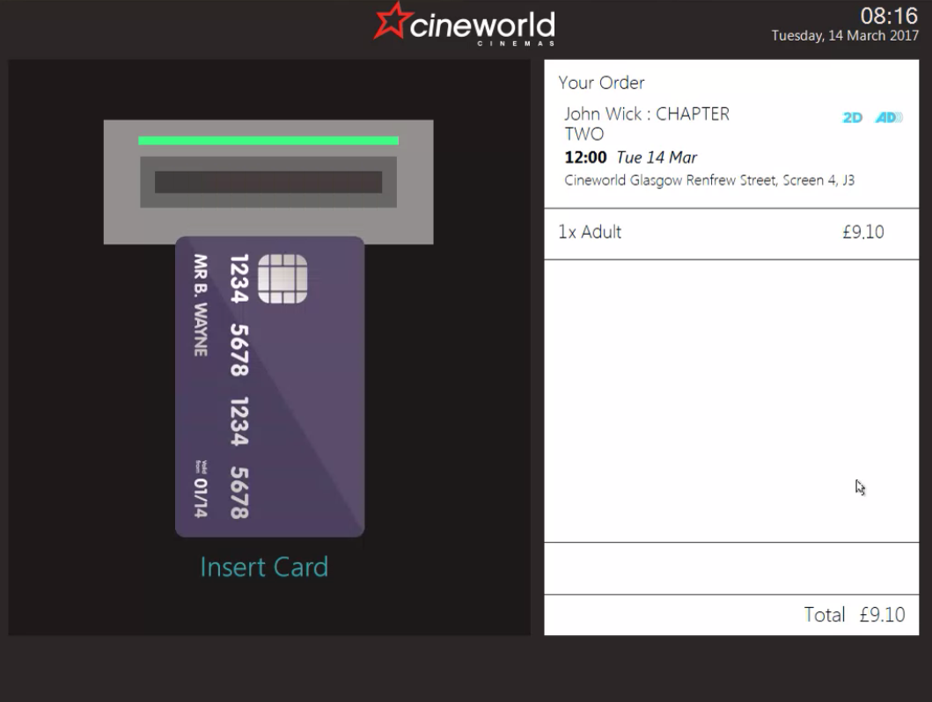

After seeing “Ready” Ocius should log in.

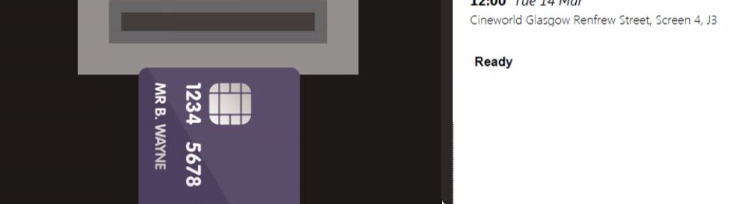

Press “alt + tab” to make sure Ocius has disappeared. 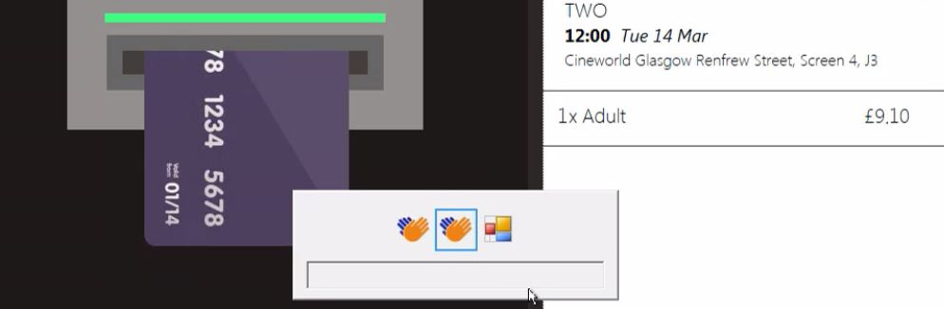

Most common issue will be that:

1. After attempting to pay Ocius will not log in.

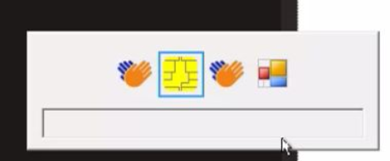

In this case re-log to administrator and proceed with troubleshooting

1. **First cause of the issue:**

**-Check if there is an issue with temporary profile on ATM.**

When logging in to administrator you may see this popping up in right bottom corner:

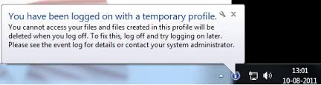

This may be also diagnosed by opening command prompt.

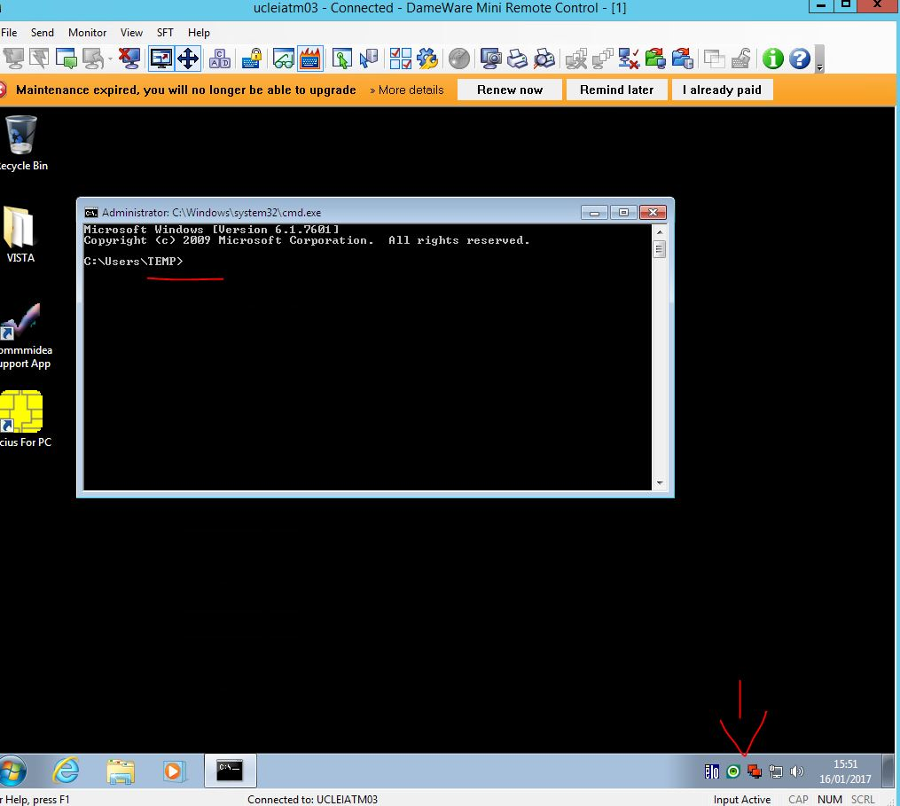

As you can see above this issue very often is related to “ESET” antivirus.

First uninstall antivirus by going to “Add or remove programs”

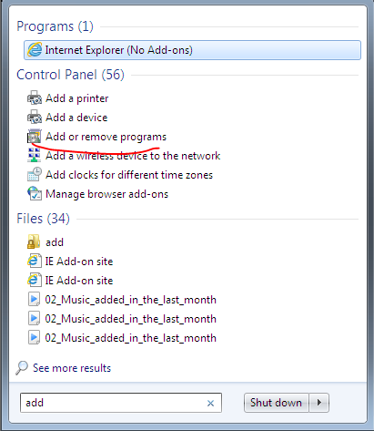

Remove ESET by uninstalling it (password can be found in keepass). This will guarantee this won’t happen again right after you have rebooted ATM.

After that open “regedit.exe”

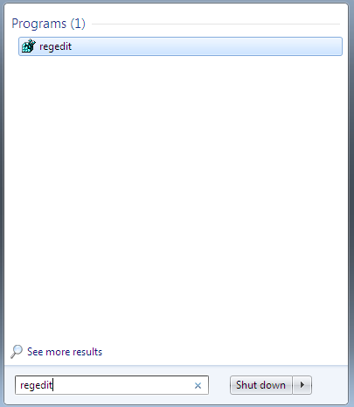

Navigate to HKEY_LOCAL_MACHINE-> SOFTWARE->MICROSOFT->WindowsNT->CurrentVersion->ProfileList

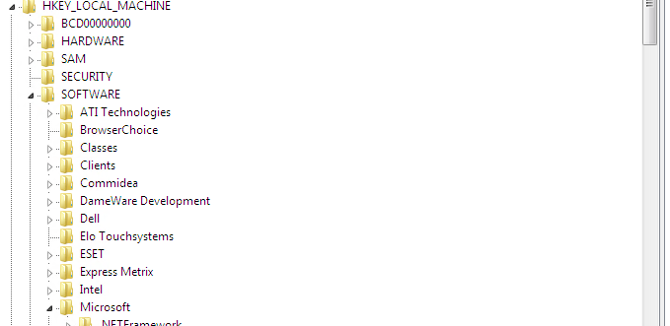

Profiles ending in “.bak” are the proper profiles, they were changed by temporary profiles.

This is how to fix it:

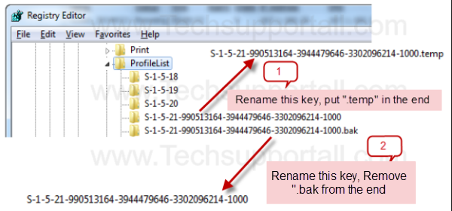

After applying all changes reboot the ATM.

1. **Second cause of the issue:**

First go to Oicus and check if there is connection between ATM and PED via ocius.

Open ocius, press F4 and type in config PIN. Go to app settings, config pinapd and check if PED is being detected on com1 or com2 both for “securaintegrated “ and “secura”

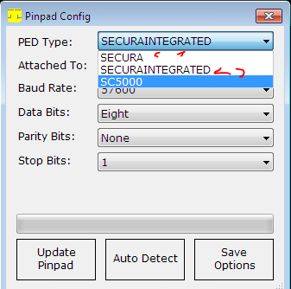

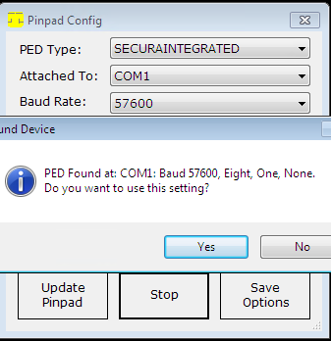

If PED is not being detected neither on “SECURAINTEGRATED” or “SECURA” on both com ports this is a hardware issue.

If PED is detected make sure Ocius configuration is correct.

Once you made sure all this is correct and ocius still won’t log in do the fallowing:

Navigate to ‘’Regedit” and go to HKEY_LOCAL_MACHINE- > SOFTWARE->

And delete “Commidea”

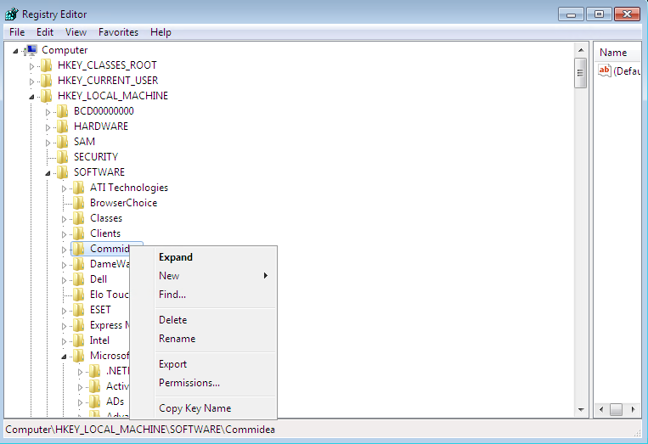

After that open Ocius for PC , try to log in using false credentials (example type in 1 in log in ID and password”. You will see “log in failed” message.

Try to log in again this time using correct credentials (can be found in keepas)

You will see ocius updating”

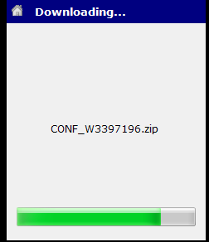

After this check if Ocius is logging in on administrator

1. **Ocius will start two times, one of them will log in however it still won’t work (accept payment on vista.)**

Re-log to administrator and check:

* Msconfig.exe navigate to startup and check if there is “Ocius for PC” there. If this is the case untick the box and click “apply”

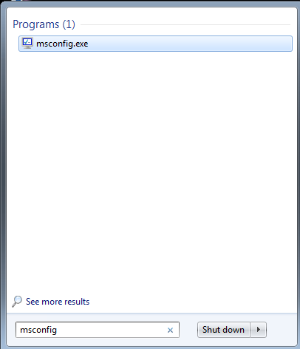

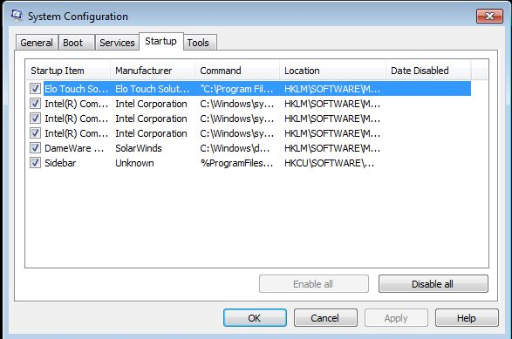

-Press windows logo in the bottom left corner of the screen and click on “All programs”

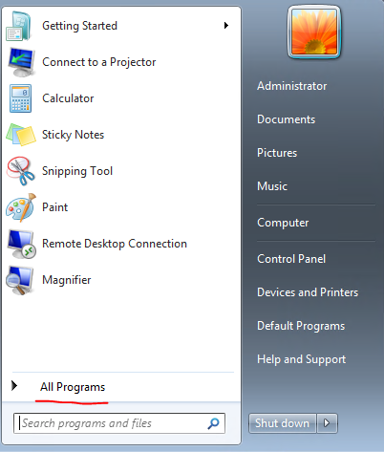

Right click on “startup” and pick “explore”

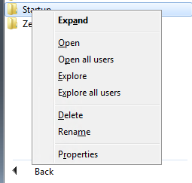

Check if the folder is empty

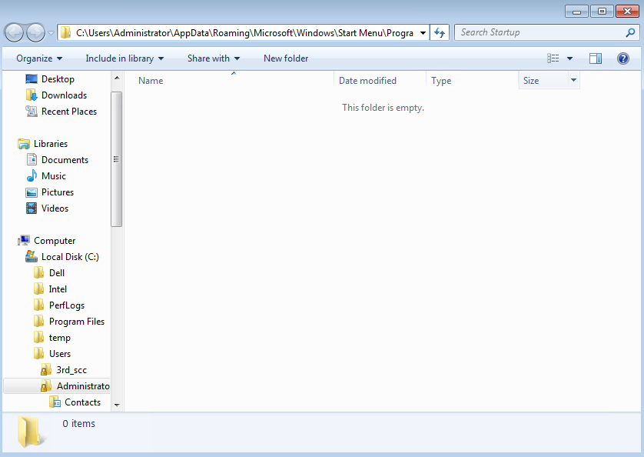

If there is shortcut to ocius there, delete it.

Check also the same path for atm user by changing “administrator” to the name of the user.

Name of the atm user will be always “ucxxxp-atm” where xxx is sites code. For example Glasgow Renfrew Street will be “GRS” therefore atm username will be “ucgrsp-atm”

After changing this press enter

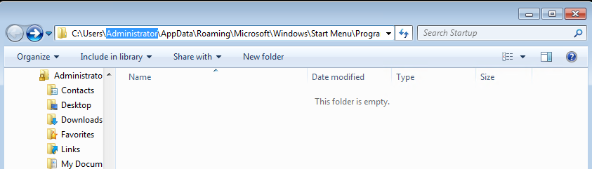

Check if this folder is empty as well

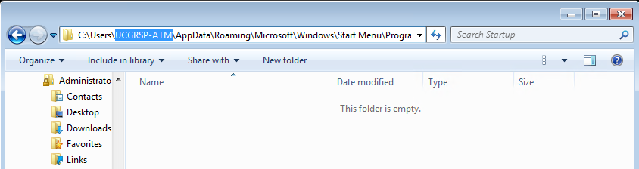

Reinstalling ocius:

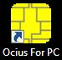When receiving information about chip and pin not working on the ATM safest bet is to start from reinstalling ocius as this also serves as troubleshooting process.

First re-log to administrator (see part1)

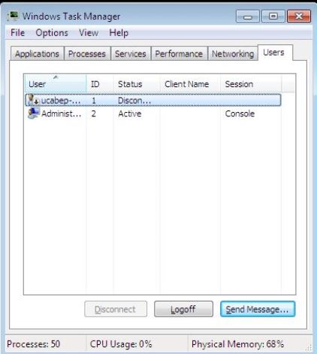

As the previous user is still logged in we need to log him out in order to proceed with reinstallation

Click “CAD” icon. Click “start task manager” and go to users tab log off user starting in “uc..”

**Find ocius installation file**:

1. Usually it is on ATM in “C:\Windows\dwrcs\Uploads.”
2. If this is not the case you can try to find install file on another ATM using file explorer to enter the same path \\ucxxxatm01\c$\Windows\dwrcs\Uploads where xxx is a site code.

for example: \\ucABEatm01\c$\Windows\dwrcs\Uploads

1. Installation file for ocius can also be found on viscin1 site (\\ucxxxp-viscin1\ where xxx is site id)

**Ocius installation**

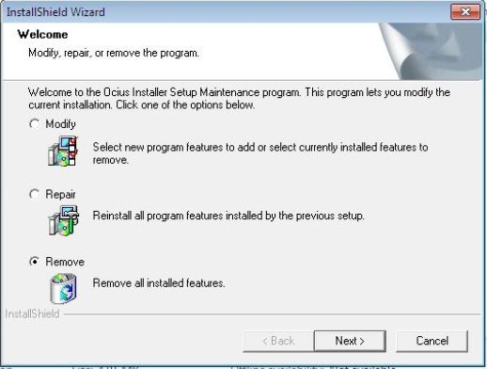**First we need to delete old ocius**

Click on setup. Chose remove.

Go to “C:\Program Files” and make sure that “Commidea” folder has been removed. If not delete it manually

**After that install ocius once more**

Go again to C:\Windows\dwrcs\Uploads and run setup once more.

Click “Next”, Click “Bypass” and “Ok” when warning pops out.

In “User name” and “Company name” type in “Cineworld Cinemas”

Procced with installation by pressing “Next” and press finish

Copy “Ocius” and “TerminalGUID.dat” to “C:\Program Files\Commidea\Ocius For PC”

**Configuring ocius:**

Start ocius from desktop. You should see this:

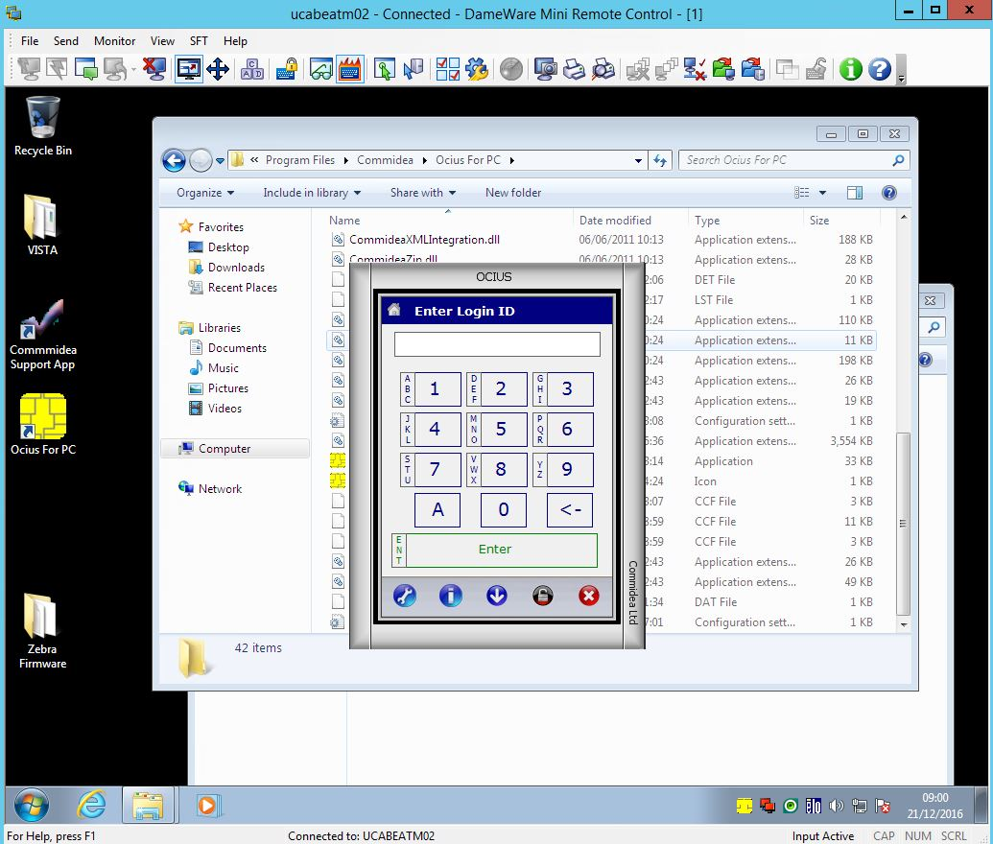

Press “F4”

Configuration pin is “2580”. After that press “enter”

Remember to input all credentials using keyboard and not OCIUS prompt as this information is confidential.

Go to:

“3. app settings” and then to “1. Config Pinpad”

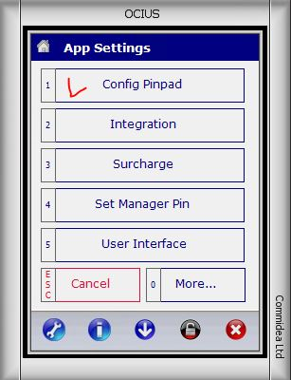

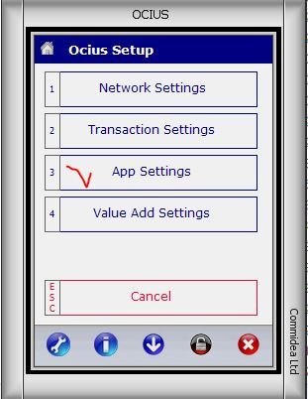

Check if those are correct:

“Ped type” for now should be ‘SECURA”

“Attached to” should stay at “COM1”

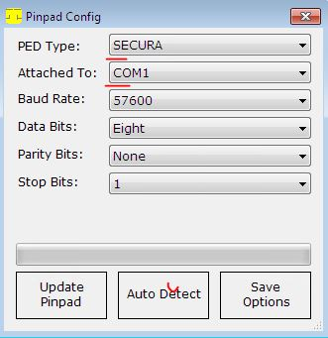

Press auto detect.

Ocius should almost instantly find PED at COM1

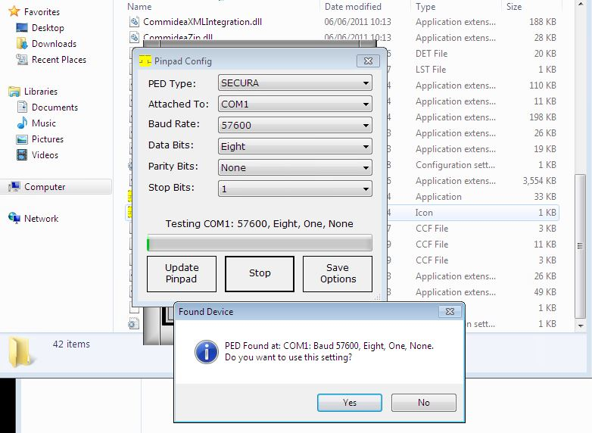

If this is not the case and you can’t see prompt “Found device” popping out procced to point “b”

Otherwise click “yes”

After that change “PED type” to “SECURAINTEGRATED” and “save options”

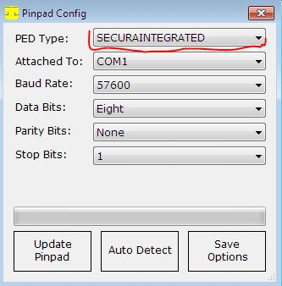

In case when chip and pin is not being detected ask the Manager or person on site to reset the cables that go to chip and pin.

If this does not help connect chip and pin to another com port (2).

Change “Attached to” on ocius to “COM2” and run auto detect once more.

If that does not help either Chip and pin or port is broken.

In “App settings” go to “5. User Interface” than to “Display Config” then “Form Options” and pick “Screen Only”

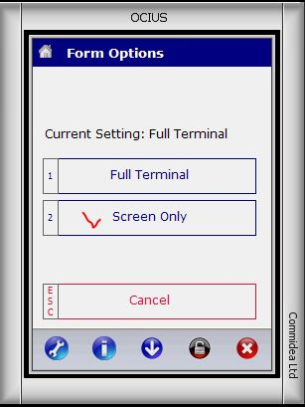

Go back to “Display Config” go to “2. Operation Mode” and pick “4. Unattended”

Go back to “App settings”. After that go to “0. More…” , “Print Settings, “1. Printer” and chose “4.Windows Printer”.

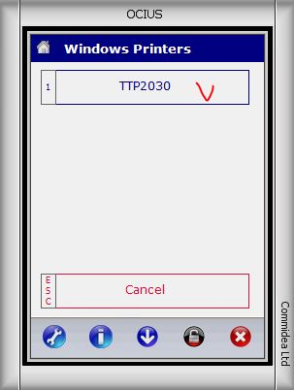

Most ATM’s use either TTP2030 or STAR printer. Pick the one that displays. In this case printer is “TTP2030”

After that go back pressing “esc” multiple times until you see “Start-up”

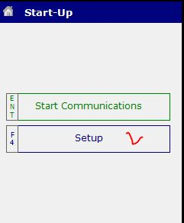

Pick Setup and enter config pin “2580” one more time

Go again to “App setting”, “More…”, “Print Settings”, “More…” and pick “6. Extended Receipt Line Line Feeds”. Input “4” in “No Of Lines”, press “enter” and go back again to “start up”

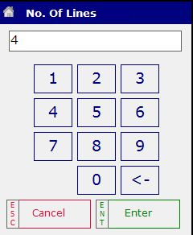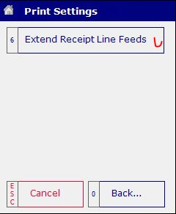

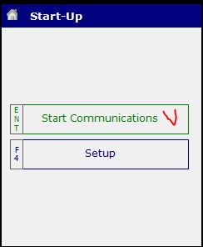Press “Start Communications”

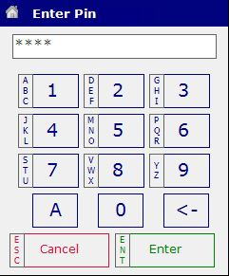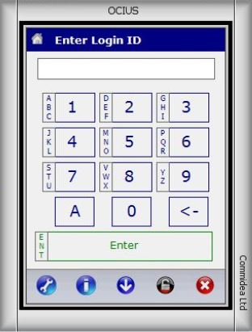

This time simply type in login ID and PIN (they can be found in keepass).

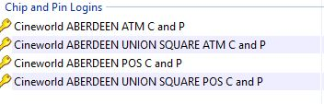

Remember that:

-Login and PIN are always the same.

-NOTE that those are unique for each site

Replace account

Manager pin is always 5555

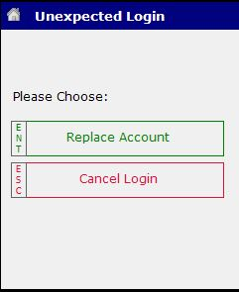After that chip and pin will start to download updates

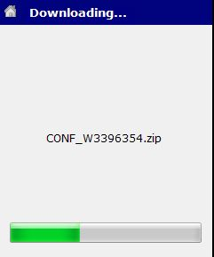

**Security settings**

After that ocius is configured. Last thing to do is making sure that security settings are correct.

Go to “C:\Program Files” and right click on “Commidea” folder picking “Properties”.

Go to “security” tab

Press “edit”

Make sure that “Users” and “Administrators” and “Trustedinstaller” have all permissions ticked

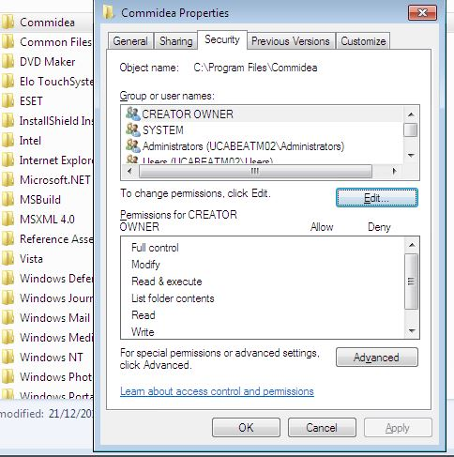Click “Apply”

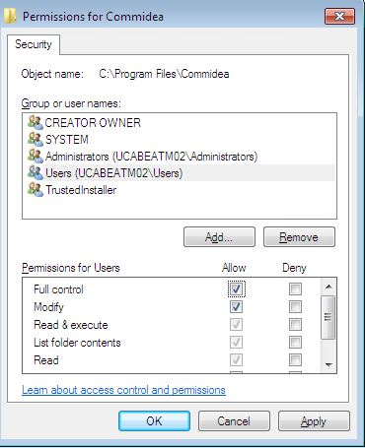

After all is done reboot the ATM

1. **Printer issues**

Most common issues with ATM’s are related to printers

To start troubleshooting printer connect to ATM using “Dame Ware” and re-log to administrator.

After that go to “Devices and Printers” ( Control Panel\Hardware and Sound\Devices and Printers)

Depending on site there are 3 types of printers that you can find here and they have different settings:

1. **Zebra TTP2030**

**Troubleshooting summary and hotfixes:**

1. **Is the printer being detected in “devices and printers”**
2. **Printer is detected and shows green tick sign- Continue troubleshooting**
3. **Printer shows as “unknown device”-**

**Solution: reset the cables and reinstall drivers.**

1. **Printer is being detected however it has a warning status:**

**Solution: Apply fix accordingly to issue displayed on the printer. Most common issue is paper jamming.**

1. **What happens when running “test print”:**
2. **Printer jammed**

**Solution: check the settings, if it makes grinding noise or keeps jamming with correct settings this is a hardware issue.**

1. **Printer will print only on administrator/ vista will crash but printer is fine**

**Solution:**

**-Check the name of the printer**

**-check the security settings on the printer**

**-Check xml settings**

This is the most common printer. It’s attached in Neo V1, V2 and ProTouch ATMs.

This is how printer without any issues should look. The red bracket is the space that will display errors details.

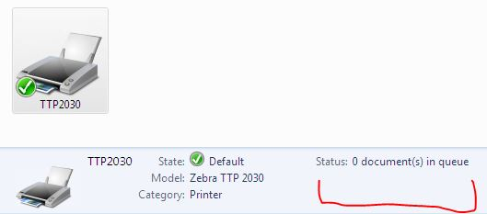

Most common errors are:

-Paper jammed.

This error will usually crash vista at start.

In this case you should call the site and ask the manager to check the printer for any jams/ trash hindering printer.

-Toner/ink low

The printer does not use toner. However this error may suggest that printer is not configured properly.

-Printer has disconnected:

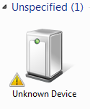

Solution:

-Disconnect the printer by unplugging the usb cable and plugging it back in.

- Right click on “Unknown device”, go to hardware, properties, driver, uninstall.

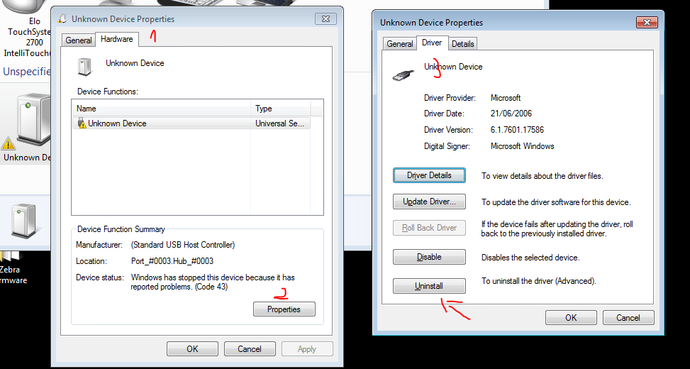

After that go to device manager, right click on anything and select “Scan for hardware changes”

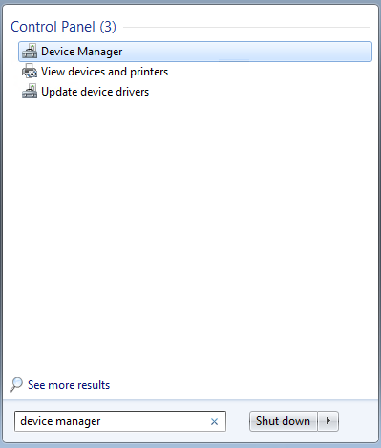

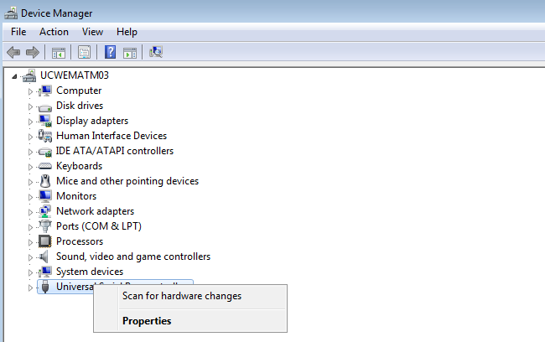

After that you will see if the device drivers were successfully installed.

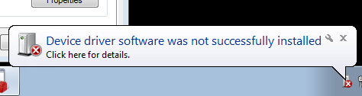

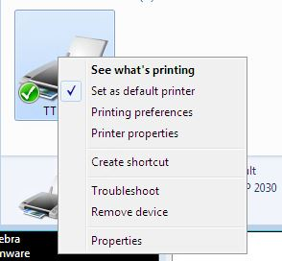When printer is causing any issues check if the settings are correct by right clicking on printer and going to “printer properties”

In General tab:

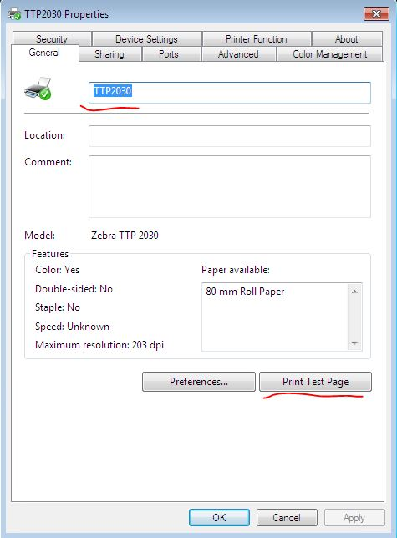Name of the printer should always be TTP2030

From default this is set as Zebra TTP 2030 -

If this is the case printer won’t work on VISTA

You can also check if printer is still jamming by printing test page

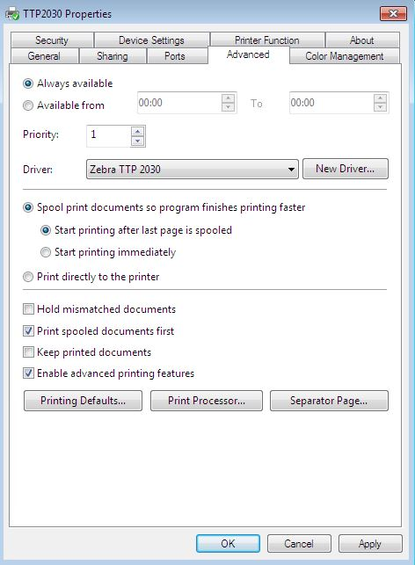In Advanced tab:

For Zebra TTP2030 proper settings are **“spool print documents so program finishes printing faster”**

And

**“start printing after last page is spooled**”.

Other settings may cause printer issues – please bear in mind that this setting is using windows spooling services so you need to make sure this service is running.

In case if there are some problems with the service you may set **“Print directly to the printer”.**

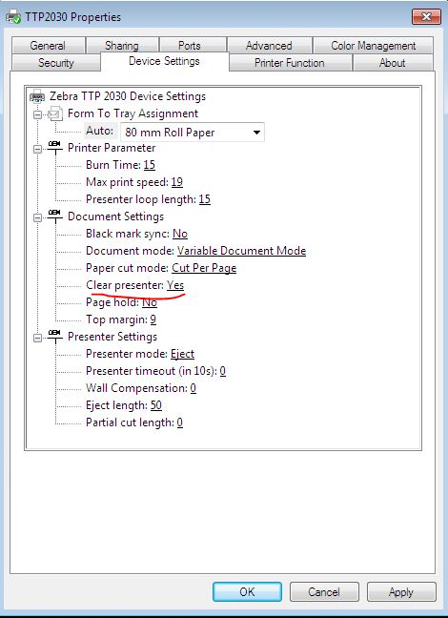In Device Settings tab:

You should check if clear presenter is changed to “Yes”. This is set up for purpose to let the printer clear the presenter and ‘spit’ the ticket out of the printer roll to make sure the printer won’t jam if there are other tickets printed in the same transaction.

In Security tab:

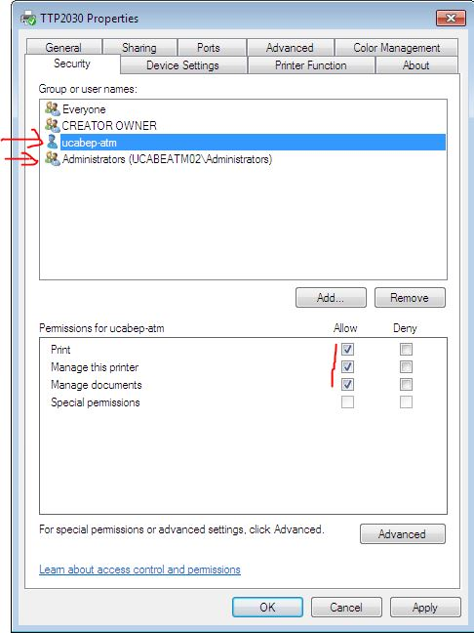User account and administrator should have all permissions allowed. This is simply because otherwise the users won’t be permitted to print using that printer.

After all has been checked press apply.

If all settings are correct and you are able to print test page check settings on ocius (go to part 1.)

**Zebra drivers and utility software:**

**Zebra TTP drivers**:

If the printer is being detected as unknown device or is causing other software related issues on administrator it can be fixed by reinstalling drivers.

Log off user

Uninstall Zebra driver

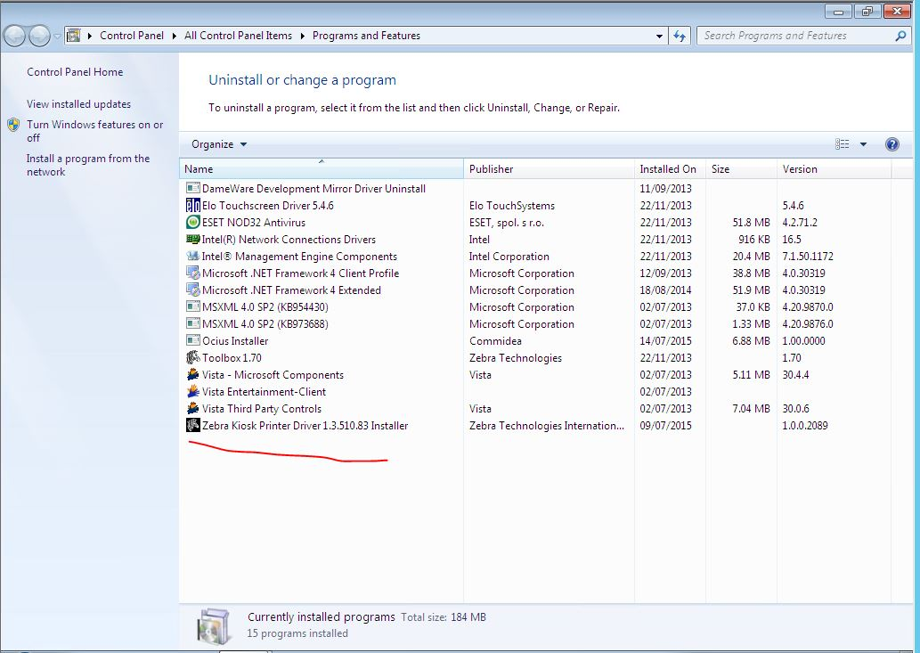

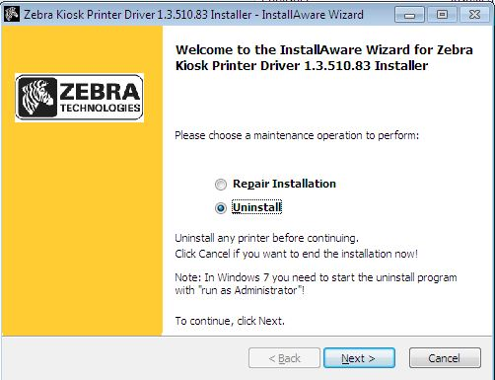

**Install zebra drivers**

Zebra drivers can be found on:

1. ATM in “C:\Windows\dwrcs\Uploads”
2. On another atm on the same site

\\ucXXXatmYY\c$\Windows\dwrcs\Uploads

Where XXX is site code and YY is ATM number

1. Viscin1 server

\\ucXXXp-viscin1\ where XXX is site id.

Simply as any other driver. Open the install file and go next. Accept the terms and conditions.

**Printer spooler** **C:\Users\dga\Desktop\atm guides\zebra\services.JPG**

If there are too many print requests and printer is jamming this may be fixed by going to:

Services. C:\Users\dga\Desktop\atm guides\zebra\services.JPG

Search for “Printer Spooler” and click “restart”.

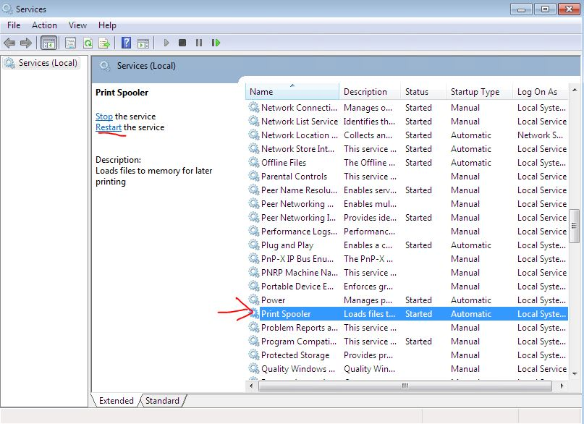

**Zebra toolbox:**

This is useful tool that can be found at:

C:\Program Files\Zebra\Toolbox

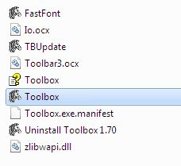

Run zebra and pick 210\216 mm

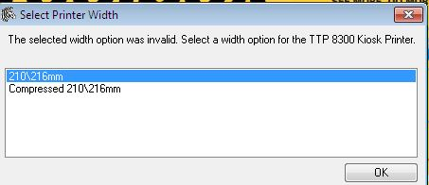

Go to port and select USB printer TTP 2030 Kiosk Printer

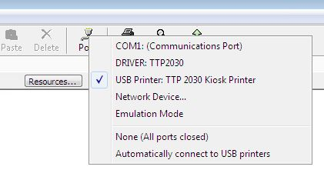

Go to “Tools” and select “Status Enquiry”

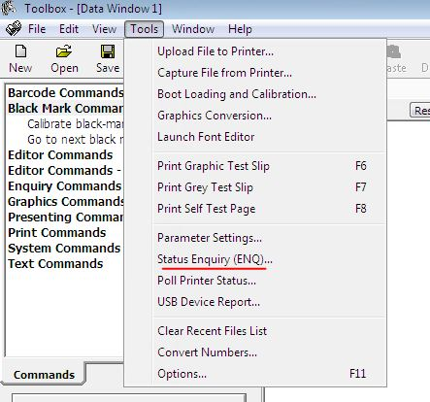

After that you can check detailed information about printer

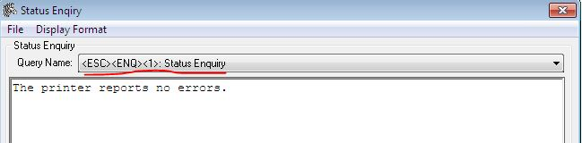

1. **Star (Actual model is Sanei SK1-31s – It’s used in V1 ATMs)**

**Troubleshooting and hotfixes:**

**!!Most common issue: Printer will show paper issue!!**

**Fix: go to Printer properties and untick “Enable bidirectional support”**

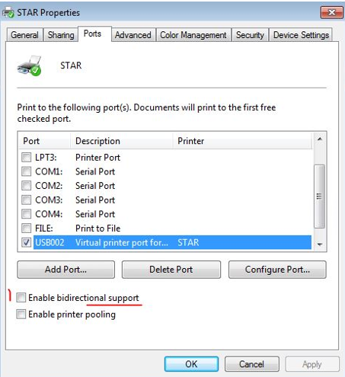

**If this is not the case continue with troublehooting:**

1. **Is the printer being detected in “devices and printers”**
2. **Printer is detected and shows green tick sign- Continue troubleshooting**
3. **Printer shows as “unknown device”-**

**Solution: reset the cables and reinstall drivers.**

1. **Printer is being detected however it has a warning status:**

**Solution: Apply fix accordingly to issue displayed on the printer. Most common issue is paper jamming.**

1. **What happens when running “test print”:**
2. **Printer jammed**

**Solution: check the settings, if it makes grinding noise or keeps jamming with correct settings this is a hardware issue.**

1. **Printer will print only on administrator/ vista will crash but printer is fine**

**Solution:**

**-Check the name of the printer**

**-check the security settings on the printer**

**-Check xml settings**

**Star is second most popular printer**

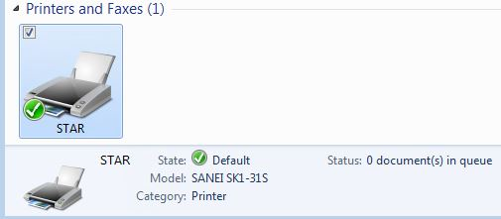

Start can display same errors that TTP2030 does.

However those are key differences in settings:

General settings:

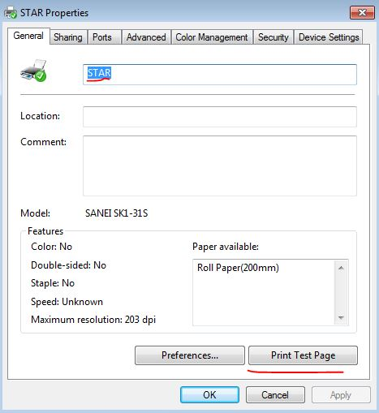Name should be “STAR”

You can test print as well

Ports tab:

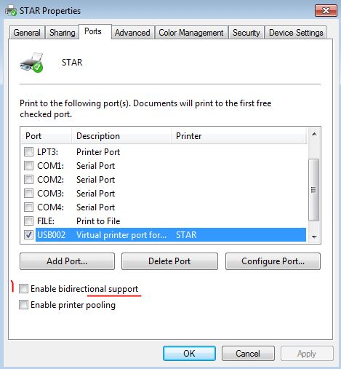“Enable bidirectional support”

Should be off – if it’s on it will show you an exclamation mark in the printer status and the printer will claim there is a paper problem.

Security tab:

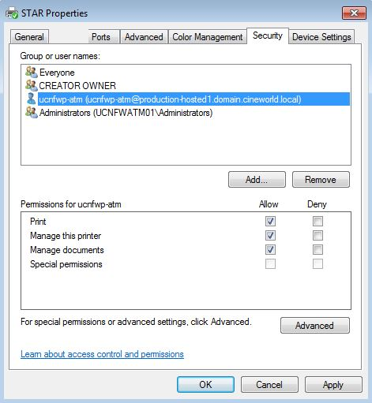User and admin should have all permissions

(Same as in TTP2030)

1. **STAR TUP992**

**Troubleshooting and hotfixes.**

1. **Are you able to find printer on any COM port in “Star Micronics Printer Utility”.**
2. **Yes- continue troubleshooting, remember on which com port it was faound.**
3. **No- Check paper alignment, paper sensor and cables on the printer.**
4. **Printer is being detected however it won’t print on vista.**

**-Check if there is correct comport and atm name in vss Hardware cofig.**

**-check if there is correct comport set in Ocius,**

Start troubleshooting by:

Relog on to administrator.

Open “Star Microncs Printer Ultility”

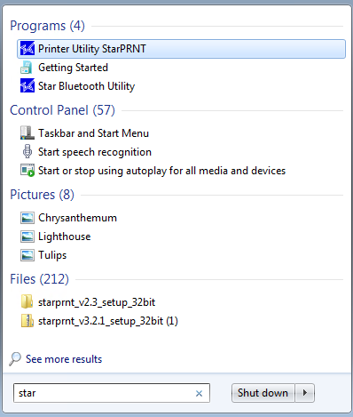

Click “Check” in “current connection”

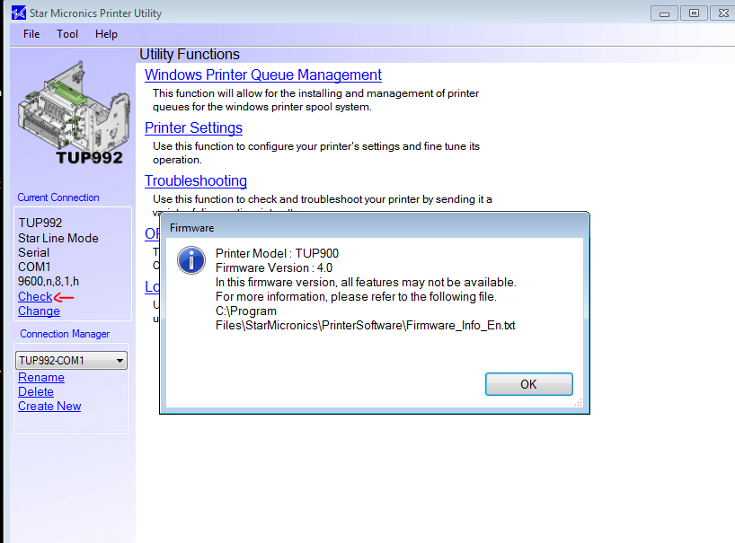

If the printer is not being detected this is what will come up:

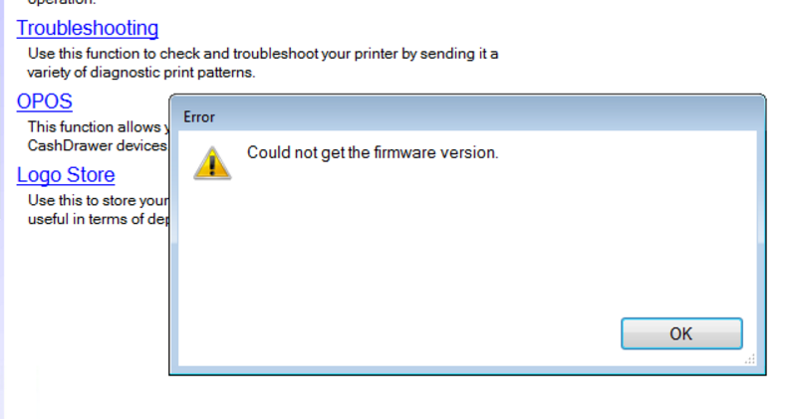

In this case pick “change”



Select TUP992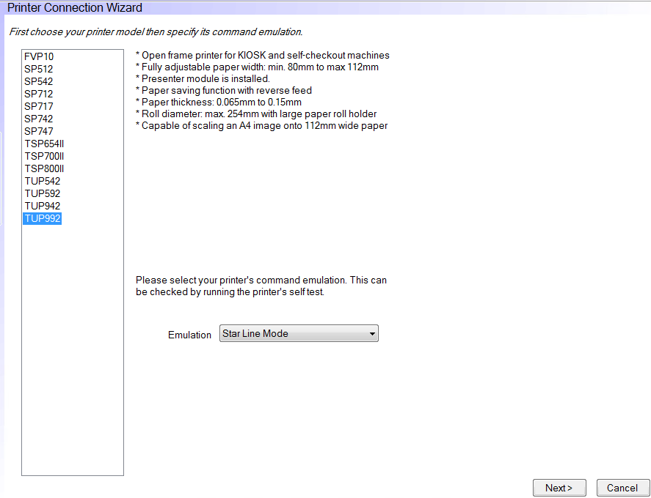

Select serial and select other comports to test if printer is connected to them (com01, com02 etc.)

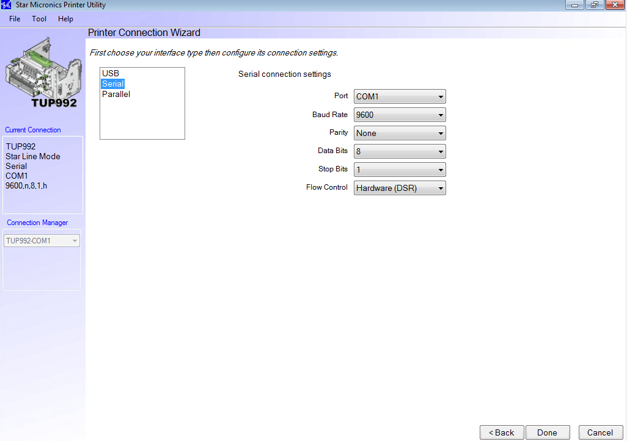

After that select “check”.

If the printer is not being detected on any comport:

1. Check if the paper is aligned properly and there are no issues with the paper sensor.

This is very common issue. This model of a printer will show as OFFLLINE if paper is aligned incorrectly.

1. Check the cables that go to the printer.

If the printer is being detected on any com, however it won’t print on vista:

1. Check if the COM port detected in Star utility is set to the same one on ocius.

Open “Ocius for PC” -> “App Settings”- > more-> print settings-> printer->more-> com port printer->

Select the same COM that printer is currently connected to.

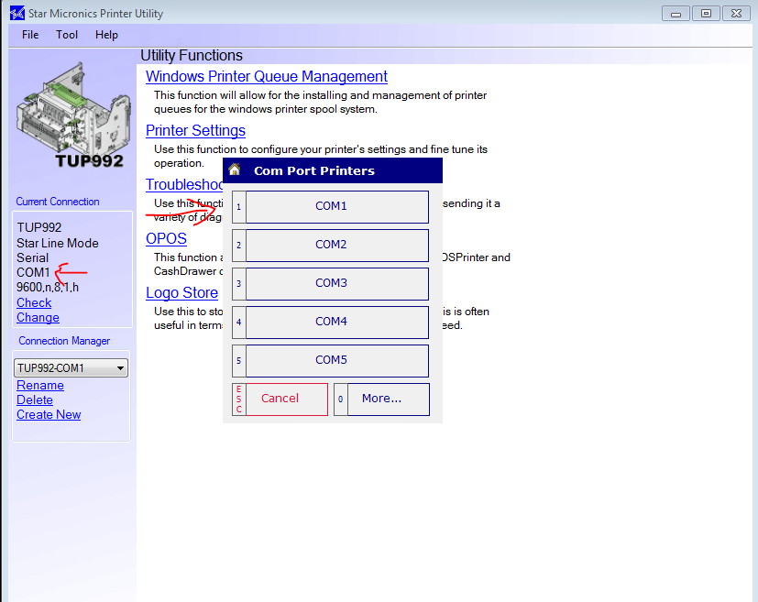

After that check if the same COM is set up in VssClientHardwareConfig.xml

( location to file C:\VISTA\VistaKiosk\Config)

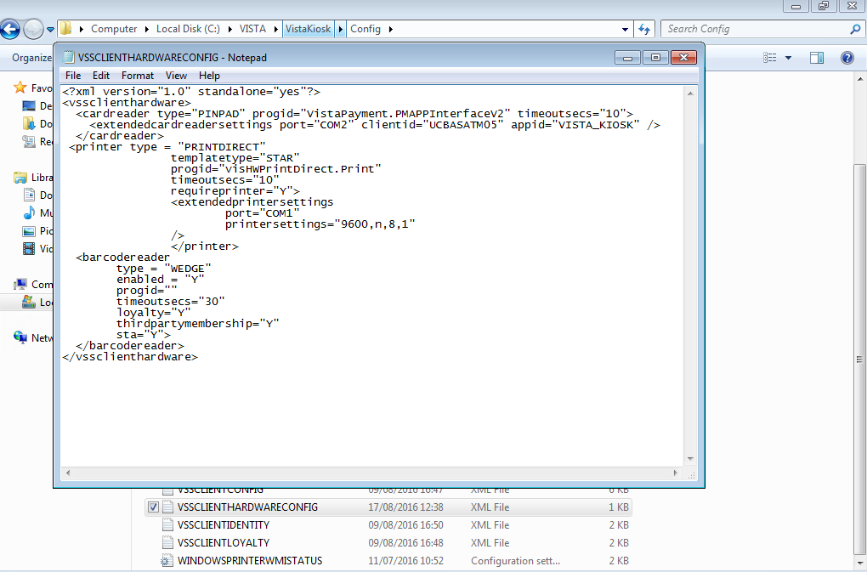

1. **XML setup**

Vista uses 5 files for configuration that are unique for on every ATM:

REMOTESERVERCONFIG

VSSCLIENTCONFIG

VSSCLIENTHARDWARECONFIG

VSSCLIENTIDENTITY

VSSCLIENTLOYALTY

Those files can be accessed without logging to ATM by accessing this path using internet explorer on jumpbox:

\\ucXXXatmYY\c$\VISTA\VistaKiosk\Config

Where XXX is site id and YY is ATM number.

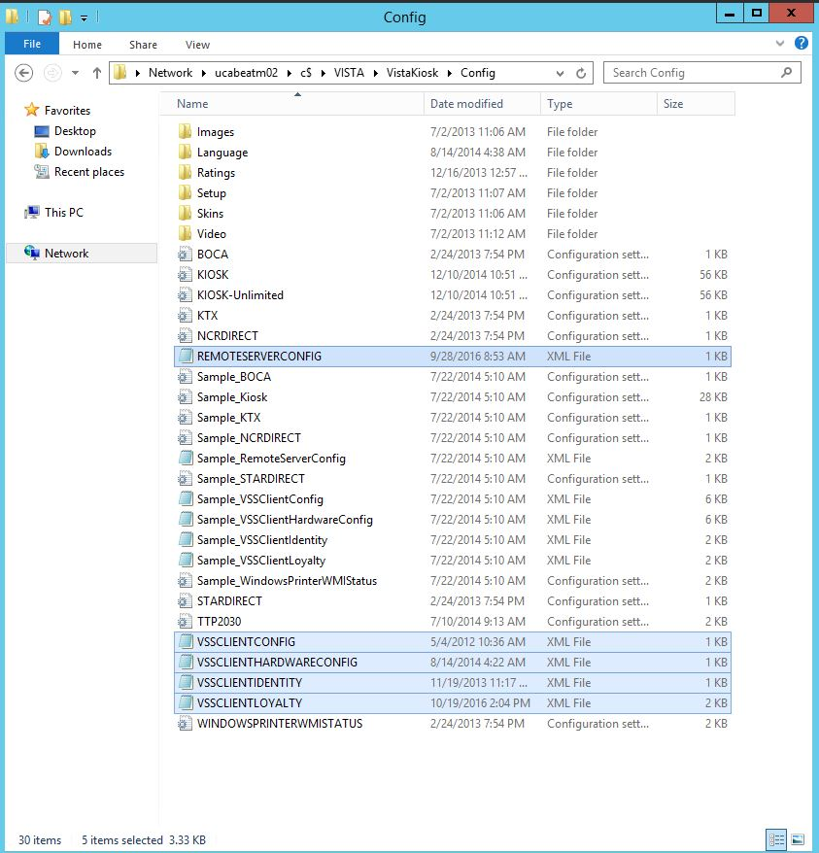

**REMOTESERVERCONFIG**

Serverid and url should be either site viscin1 name or IP address

-10.202.XX.2 is viscin1 ip. XX is unique number for site. For example Aberdeen will have either:

Ip 10.202.50.2 or ucabep-viscin1

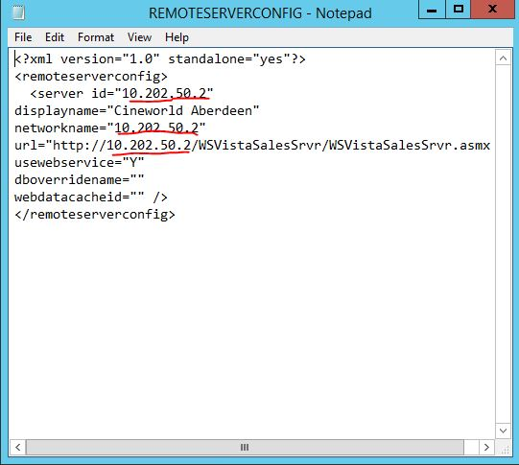

**VSSCLIENTCONFIG**

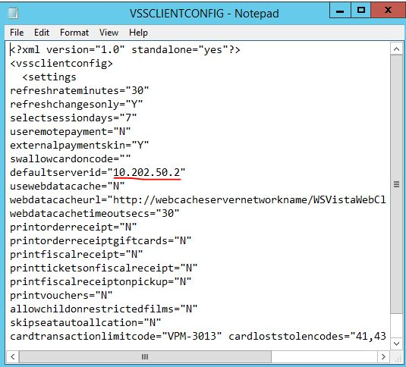

Same as with REMOTESERVERCONFIG this should be either name of viscin1 or ip of viscin1 for particular site.

**VSSCLIENTHARDWARECONFIG**

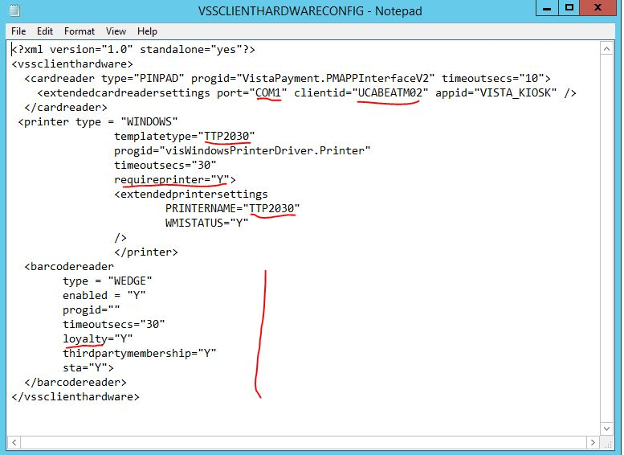**port**=”com1”

This should be the same for most sites

**Client id**

should always be:

UCXXXATMYY where

XXX- site code

YY- ATM number

**Template type** and **Printername**

This depends on printer connected to ATM. In most cases this will either be “STAR” or “TTP2030”

**Requireprinter**: this varies from site to site. If this is “Y” Vista will crash on start when printer will fail initializing

**Barcodereader:** on sites where ATM’s use loyalty, loyalty should be “Y”. if this is set to “N” or there is no string for this ATM’s won’t be able to use loyalty cards/

**VSSCLIENTIDENTITY**

Client id should be in most cases 111.111.222.22Y

Where “Y” is number of the ATM

For example for ATM01 this should be 111.111.222.221

Important part regarding this is that two ATM’s should NOT have the same client id as this may cause issues.

“Workstation id” and “payment client id” should always be UCXXXATMYY

Where XXX is site id and YY is the number of ATM



**VSSCLIENTLOYALTY**



LMC_strCinemaID

-This is digit that is unique for a site. You can find those for all sites in excel file “List of sites” or in the site SQL under tbl.LoyaltyModuleConfig under string LMC_strCinemaID

ServiceURL

This should always be: http://10.130.6.10/visLoyalty/VistaLoyalty.asmx

1. **Touchscreen.**

**Troubleshooting and fixes:**

**Check how touch option performs on administrator when using paint**

1. **Is it recording touch but is not aligned properly?**

**Solution: Calibrate it using ELO software**

1. **It is recording touch, showing white circle on point touched, however won’t interact with software on screen.**

**Solution: restart “Tablet PC input service” in services**

1. **It works fine on administrator but not on vista.**

**Solution: Change “AutoClickNavigation=” in Kiosk.ini to opposite value than it is currently set (“N” to “Y”).**

If the touchscreen is not responsive:

Re-log to administrator

Open paint and ask person on the other end to draw something trying to cover as wide area of the paper as possible:

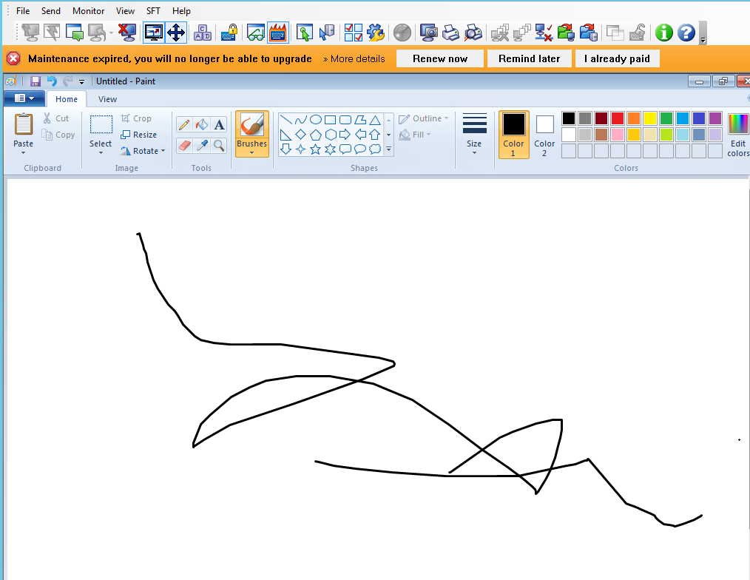

There may be 3 different outcomes for this test:

1. **If the screen is not calibrated properly/ there is a gap between point touched and point recorded on the screen- calibrate the screen**

Calibrate the screen by clicking ELO icon in right bottom corner of the screen, select align and run the calibration.

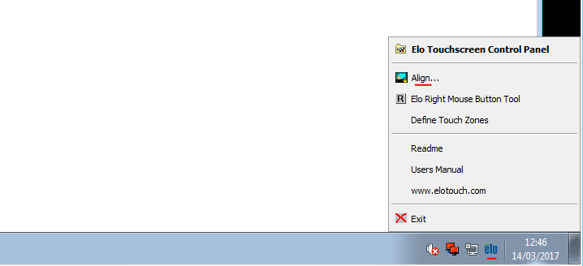

Cross hair on the screen should be touched and pressed by a finger.

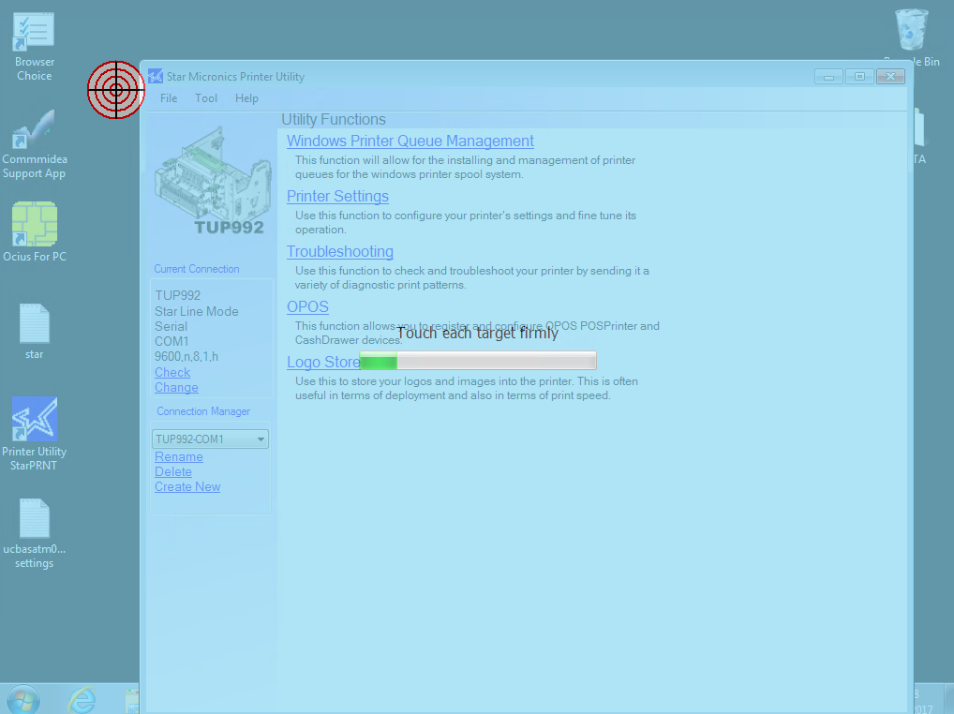

After calibrating reboot the ATM.

1. **If the screen does not record any commands on the software (it won’t leave a mark on paint for example) however you will see the screen reacting to touch in the place touched (very often there will be a white circle appearing around the place touched)**

**Fallow the fix bellow:**

Go to services-> Find “Tablet PC Input Service” and restart it

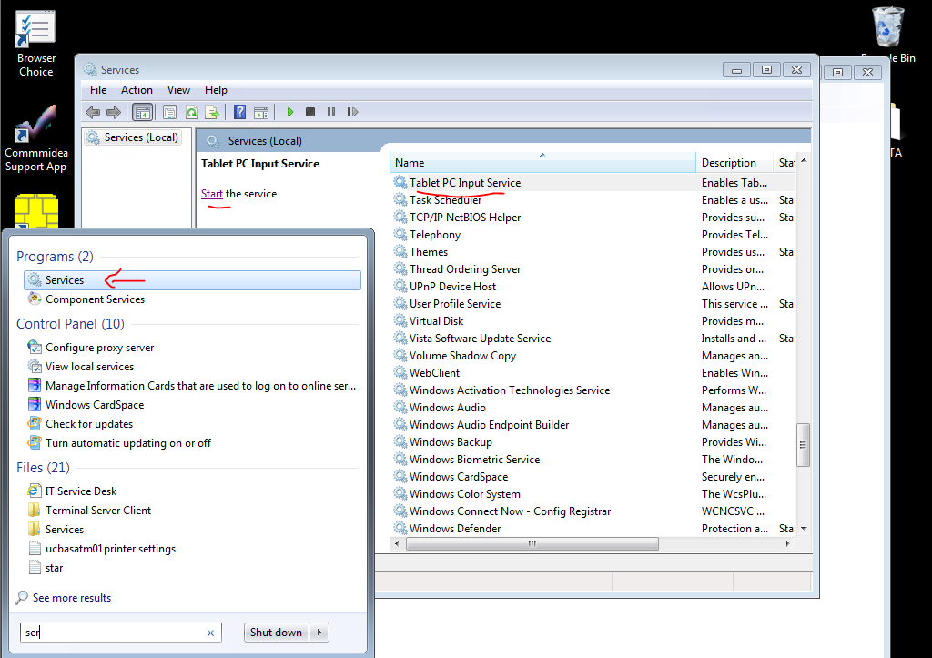

1. **Touchscreen works perfectly on administrator, however it will still be not responsive on vista.**

**Go to C:\VISTA\VistaKiosk\Config, and open KIOSK.ini**

**Under [Appearance] check the last string “AutoClickNavigation=Y”**

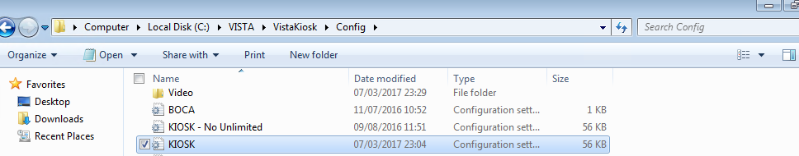

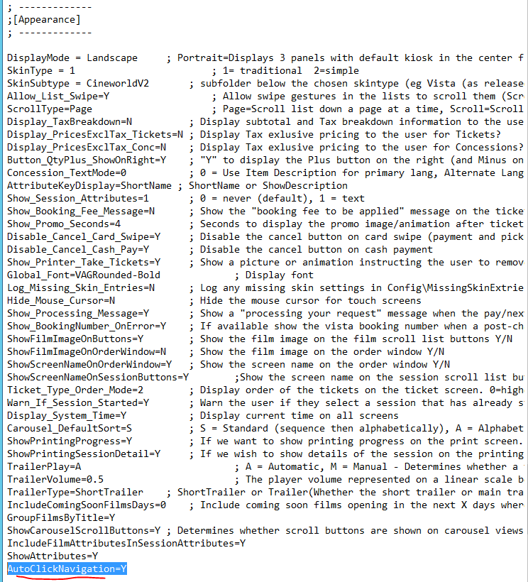

**If “AutoClickNavigation=” is set to “Y” change it to “N”**

**Adding this version may help if it is absent from kiosk.**

**However on some versions of vista it will cause troubles (example West India Quey).**